Complex task 1:
Problem: A fitness tracker stores the number of steps for each day in a month.
Find the average steps and how many days had more steps than the average.
Pattern: Summation, Counting , Decision
Specification: Specification editor
In: size∈N, steps∈Z[1..size]
Out: avg∈R, count∈N
Fn: average: Z[1..size] -> R,
average(a) = SUM(i=1..size, a[i]) / size
Pre: size > 0
Post: avg = average(steps) and
count = COUNT(i=1..size, steps[i] > avg)
Algorithm: Structogram editor
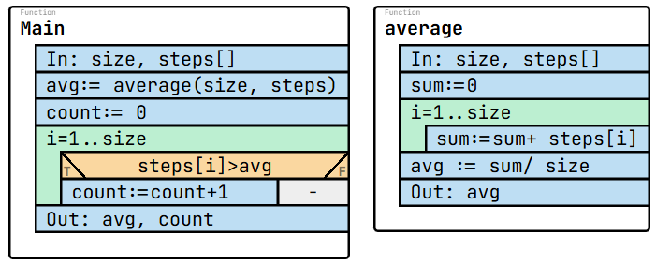
Test cases:
size: 3  steps: [1000, 2000, 3000]  avg: 2000  count: 1 | size: 3  steps: [5000, 5000, 5000]  avg: 5000  count: 0 | size: 4  steps: [0, 1000, 0, 1000]  avg: 500  count: 2 | size: 1  steps: [2000]  avg: 2000  count: 0 | size: 4  steps: [1000, 4000, 7000, 1000]  avg: 3250  count: 2

Code:
using System;
namespace Task1
{
internal class Program
{
static double Average(int[] a, int size)
{
int sum = 0;
for (int i = 0; i < size; i++)
{
sum += a[i];
}
return (double)sum / size;
}
static void Main(string[] args)
{
Console.Write("Enter number of days: ");
int size = int.Parse(Console.ReadLine());
int[] steps = new int[size];

Console.WriteLine("Enter steps for each day:");
for (int i = 0; i < size; i++)
{
steps[i] = int.Parse(Console.ReadLine());
}

double avg = Average(steps, size);
int count = 0;

for (int i = 0; i < size; i++)
{
if (steps[i] > avg)
{
count++;
}
}

Console.WriteLine("Average steps: " + avg);
Console.WriteLine("Days above average: " + count);
}
}
}
Questions:
1. Which patterns are applied in this task?
Answer: Summation, Counting , Decision
2. If all days have the same number of steps, what is count?
Answer: count = 0, because no day is strictly above the average.
3. What are missing in the following specification? (What would you write instead of <q1> and <q2>)
In: size∈N, steps∈Z[1..size]
Out: avg∈R, count∈N
Fn: average: Z[1..size] -> R,
average(a) = <q1> (i=1..size, a[i]) / size
Pre: size > 0
Post: avg = average(steps) and count = <q2> (i=1..size, steps[i] > avg)
Answer: <q1>= SUM , <q2>= COUNT
4. What is missing in the following algorithm? (What would you write instead of <q1> and <q2>)
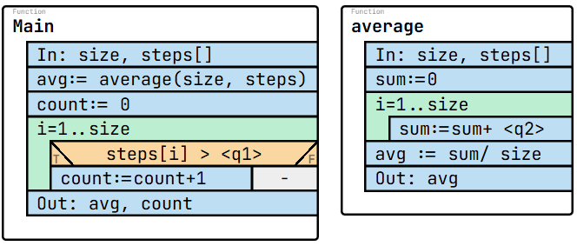
Answer: <q1> = avg, <q2> = steps[i]
5. How many times is the condition steps[i] > avg evaluated for size = 7?
Answer: 7 times.
Complex task 2
Problem: A music app tracks how many minutes a user listens to music each day.
Users want to know: “On which day did I first exceed my total weekly listening average?”
First, the total average listening time for the week must be computed, and then the system must find the first day whose value is greater than this weekly average.
Pattern: Sum, Search
Specification: Specification editor
In: size∈N, mins∈Z[1..size]
Out: avg∈R, firstAbove∈N
Fn: weeklyAvg: Z[1..size] -> R,
weeklyAvg(a) = SUM(i=1..size, a[i]) / size
Pre: size > 0
Post: avg = weeklyAvg(mins) and (,firstAbove) = SEARCH(i=1..size, mins[i] > avg)
Algorithm: Structogram editor
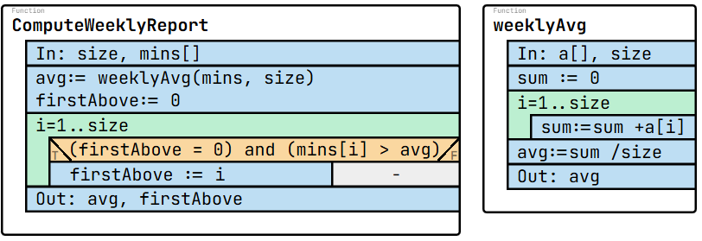
Test cases:
size: 5  mins: [10, 20, 30, 40, 50]  avg: 30  firstAbove: 4 | size: 4  mins: [5, 5, 5, 5]  avg: 5  firstAbove: 0 | size: 6  mins: [3, 8, 7, 2, 10, 6]  avg: 6  firstAbove: 2 | size: 3  mins: [100, 90, 80]  avg: 90  firstAbove: 1 | size: 7  mins: [1, 2, 3, 4, 5, 6, 7]  avg: 4  firstAbove: 5
Code:
using System;

namespace Task12
{
internal class Program
{
static double WeeklyAvg(int[] a, int size)
{
int sum = 0;
for (int i = 0; i < size; i++)
sum += a[i];
return (double)sum / size;
}

static void Main(string[] args)
{
Console.Write("Enter number of days: ");
int size = int.Parse(Console.ReadLine());

int[] mins = new int[size];
Console.WriteLine("Enter minutes listened each day:");
for (int i = 0; i < size; i++)
mins[i] = int.Parse(Console.ReadLine());

double avg = WeeklyAvg(mins, size);
int firstAbove = 0;

for (int i = 0; i < size; i++)
{
if (mins[i] > avg)
{
firstAbove = i + 1;
break;
}
}

Console.WriteLine("Weekly average: " + avg);
Console.WriteLine("First day above average: " + firstAbove);
}
}
}

Questions:
1. Which patterns are used in this task?
Answer: Summation, Search
2. What does firstAbove represent?
Answer: The first index where listening minutes exceed the weekly average.
3. What are missing in the following specification? (What would you write instead of <q1> and <q2>)
In: size∈N, mins∈Z[1..size]
Out: avg∈R, firstAbove∈N
Fn: weeklyAvg: Z[1..size] -> R,
weeklyAvg(a) = <q1>(i=1..size, a[i]) / size
Pre: size > 0
Post: avg = weeklyAvg(mins) and (,firstAbove) = <q2>(i=1..size, mins[i] > avg)
Answer: <q1> = SUM, <q2> = SEARCH
4. What is missing in the following algorithm? (What would you write instead of <q1> and <q2>)
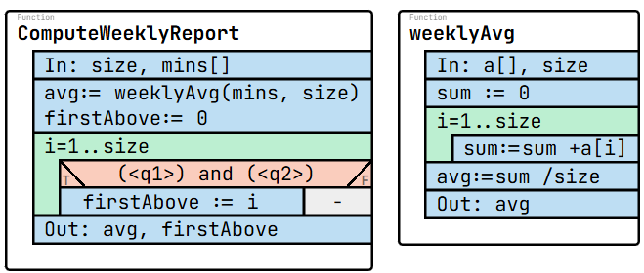
Answer: <q1> = (firstAbove = 0), <q2> = (mins[i] > avg)
5. If no day is above the average, what is firstAbove?
Answer: 0

Complex task 3
Problem: In a course, each student has scores for several assignments.
The scores are stored in a matrix: rows = students, columns = assignments.
First, calculate each student’s total score, then find the student with the highest total.
Patterns: Summation, Maximum Selection
Specification: Specification editor
In: students ∈ N, tasks ∈ N,
score ∈ Z[1..students, 1..tasks]
Out: total ∈ Z[1..students], bestStudent ∈ N
Fn: rowSum: Z[1..students, 1..tasks] x N -> Z,
rowSum(m, i) = SUM(j=1..tasks, m[i, j])
Pre: students > 0 and tasks > 0
Post: ∀i ∈ [1..students]: ( total[i] = rowSum(score, i) ) and (bestStudent,) = MAX(i=1..students, total[i])
Algorithm: Structogram editor
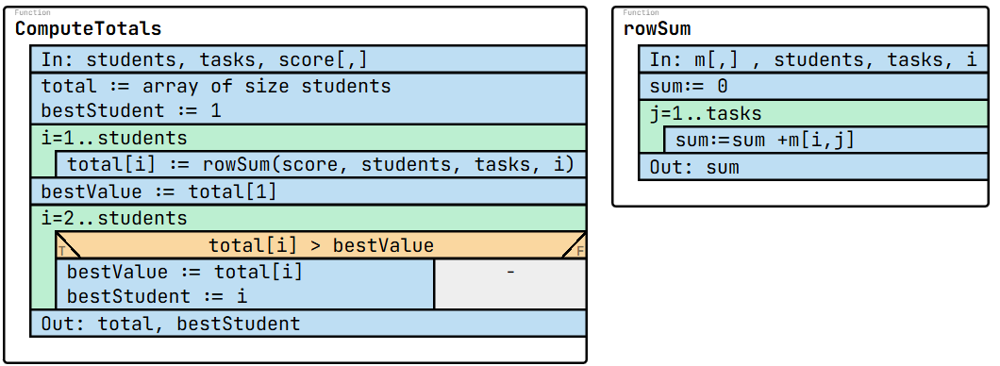
Test cases
students: 3  tasks: 3  score: [  [5, 7, 8],  [9, 1, 2],  [4, 4, 4]  ]  total: [20, 12, 12]  bestStudent: 1 | students: 2  tasks: 4  score: [  [10, 10, 5, 5],  [7, 7, 7, 7]  ]  total: [30, 28]  bestStudent: 1 | students: 4  tasks: 2  score: [  [1, 1],  [5, 3],  [2, 10],  [4, 4]  ]  total: [2, 8, 12, 8]  bestStudent: 3 | students: 3  tasks: 5  score: [  [0, 0, 0, 0, 0],  [4, 4, 4, 4, 4],  [1, 2, 3, 4, 5]  ]  total: [0, 20, 15]  bestStudent: 2 | students: 5  tasks: 3  score: [  [3, 3, 3],  [6, 2, 1],  [10, 0, 0],  [2, 2, 2],  [1, 5, 1]  ]  total: [9, 9, 10, 6, 7]  bestStudent: 3

Code:
using System;
namespace Task3
{
internal class Program
{
static int RowSum(int[,] score, int row, int tasks)
{
int s = 0;
for (int j = 0; j < tasks; j++)
s += score[row, j];
return s;
}
static void Main(string[] args)
{
Console.Write("Enter number of students: ");
int students = int.Parse(Console.ReadLine());
Console.Write("Enter number of tasks: ");
int tasks = int.Parse(Console.ReadLine());
int[,] score = new int[students, tasks];
Console.WriteLine("Enter scores:");
for (int i = 0; i < students; i++)
for (int j = 0; j < tasks; j++)
score[i, j] = int.Parse(Console.ReadLine());
int[] total = new int[students];
for (int i = 0; i < students; i++)
total[i] = RowSum(score, i, tasks);
int bestStudent = 0;
int bestSum = total[0];
for (int i = 1; i < students; i++)
{
if (total[i] > bestSum)
{
bestSum = total[i];
bestStudent = i;
}
}

Console.WriteLine("Total scores per student:");
for (int i = 0; i < students; i++)
Console.Write(total[i] + " ");
Console.WriteLine("\nBest student index (0-based): " + bestStudent);
}
}
}
Questions:
1. Which patterns are used?
Answer: Summation, Maximum selection
2. If score=[[1,1],[2,0]], what is total and bestStudent?
Answer: total = [2,2], bestStudent = 0.
3. What are missing in the following specification? (What would you write instead of <q1> and <q2>)
In: students ∈ N, tasks ∈ N,
score ∈ Z[1..students, 1..tasks]
Out: total ∈ Z[1..students], bestStudent ∈ N
Fn: rowSum: Z[1..students, 1..tasks] x N -> Z,
rowSum(m, i) = <q1>(j=1..tasks, m[i, j])
Pre: students > 0 and tasks > 0
Post: ∀i ∈ [1..students]: ( total[i] = rowSum(score, i) ) and
(bestStudent,) = <q2>(i=1..students, total[i])
Answer: <q1> = SUM, <q2> = MAX
4. What is missing in the following algorithm? (What would you write instead of <q1> and <q2>)
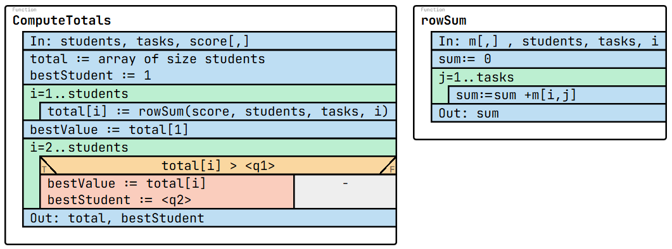
Answer: <q1> = bestValue, <q2> = i
5. What does RowSum compute?
Answer: The sum of scores for one student across all tasks.

Complex tasks 4
Problem: A reading group records how many pages each member reads in one week. Each member has a name and pagesRead.
The group leader wants to know:
- The average number of pages read per member
- How many members read more pages than this average
Patterns: Summation, Counting
Specification: Specification editor
In: size ∈ N, r ∈ Treader[1..size], Treader = (name:S x pagesRead:N)
Out: avg ∈ R, numAbove ∈ N
Fn: avgRead: Treader[1..size] -> R,
avgRead(a) = SUM(i=1..size, a[i].pagesRead) / size
Pre: size > 0
Post: avg = avgRead(r) and numAbove = COUNT(i=1..size, r[i].pagesRead > avg)
Algorithm: Structogram editor
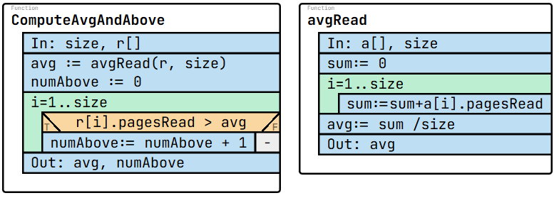

Test cases:
size: 4  r: [  {name: "Ali", pagesRead: 10},  {name: "Lia", pagesRead: 20},  {name: "Ken", pagesRead: 30},  {name: "Mia", pagesRead: 40}  ]  avg: 25  numAbove: 2 | size: 3  r: [  {name: "Tom", pagesRead: 50},  {name: "Bob", pagesRead: 50},  {name: "Amy", pagesRead: 50}  ]  avg: 50  numAbove: 0 | size: 5  r: [  {name: "Sam", pagesRead: 100},  {name: "Eva", pagesRead: 20},  {name: "Leo", pagesRead: 80},  {name: "Ivy", pagesRead: 60},  {name: "Jay", pagesRead: 40}  ]  avg: 60  numAbove: 2 | size: 4  r: [  {name: "Ann", pagesRead: 5},  {name: "Rob", pagesRead: 15},  {name: "Kim", pagesRead: 25},  {name: "Dan", pagesRead: 35}  ]  avg: 20  numAbove: 2 | size: 6  r: [  {name: "Zoe", pagesRead: 12},  {name: "Ray", pagesRead: 30},  {name: "Kai", pagesRead: 27},  {name: "Eva", pagesRead: 35},  {name: "Max", pagesRead: 18},  {name: "Sue", pagesRead: 1}  ]  avg: 20.5  numAbove: 3

Code:
using System;
namespace Task14
{
internal class Program
{
struct Reader
{
public string name;
public int pagesRead;
}
static double AvgRead(Reader[] a, int size)
{
int sum = 0;
for (int i = 0; i < size; i++)
sum += a[i].pagesRead;
return (double)sum / size;
}

static void Main(string[] args)
{
Console.Write("Enter number of readers: ");
int size = int.Parse(Console.ReadLine());

Reader[] r = new Reader[size];
Console.WriteLine("Enter name and pages read:");
for (int i = 0; i < size; i++)
{
Console.Write("Name: ");
r[i].name = Console.ReadLine();
Console.Write("Pages read: ");
r[i].pagesRead = int.Parse(Console.ReadLine());
}
double avg = AvgRead(r, size);
int numAbove = 0;
for (int i = 0; i < size; i++)
{
if (r[i].pagesRead > avg)
numAbove++;
}
Console.WriteLine("Average pages read: " + avg);
Console.WriteLine("Number of readers above average: " + numAbove);
}
}
}
Questions:
1. Which patterns are used here?
Answer: Summation, Counting
2. What does avgRead compute?
Answer: The average pagesRead value over all readers.
3. What are missing in the following specification? (What would you write instead of <q1> and <q2>)
In: size ∈ N, r ∈ Treader[1..size], Treader = (name:S x pagesRead:N)
Out: avg ∈ R, numAbove ∈ N
Fn: avgRead: Treader[1..size] -> R,
avgRead(a) = <q1>(i=1..size, a[i].pagesRead) / size
Pre: size > 0
Post: avg = avgRead(r) and numAbove = <q2>(i=1..size, r[i].pagesRead > avg)
Answer: <q1> = SUM, <q2> = COUNT
4. What is missing in the following algorithm? (What would you write instead of <q1> and <q2>)
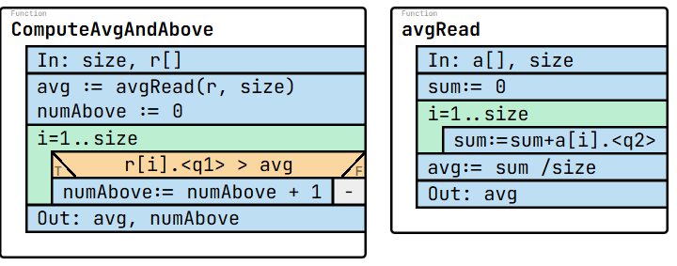
Answer: <q1> = pagesRead , <q2> = pagesRead
5. For readers = [3, 7, 5], what is avg and numAbove?
Answer: avg = 5, numAbove = 1 (only 7).

Complex tasks 5
Problem: A list of measurements is collected during an experiment. One of these measurements is chosen as the reference value. We want to find all measurements that are close to the reference, meaning all values that differ from it by no more than a given tolerance.
Pattern: Minimum selection, Search
Specification: Specification editor
In: size ∈ N, tol ∈ Z, val ∈ Z[1..size], refVal ∈ Z
Out: matchCount ∈ N, ref ∈ Z, match ∈ Z[1..matchCount]
Fn: isRef: Z x Z -> L,
isRef(x, refVal) = (x = refVal)
Pre: size > 0
Post: (,refIndex) = SEARCH(i=1..size, isRef(val[i], refVal)) and
ref = val[refIndex] and (matchCount, match) = MIS(i=1..size, abs(val[i] - ref) ≤ tol, val[i])
Algorithm: Structogram editor
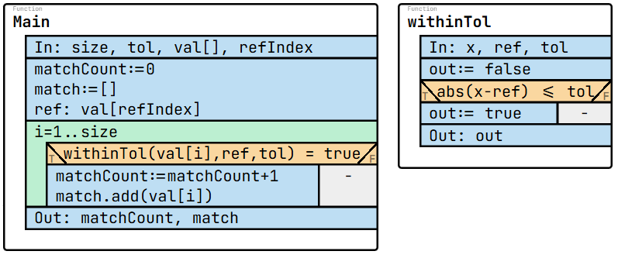

Test cases:
size: 5  tol: 2  val: [5, 7, 9, 4, 6]  refIndex: 2  ref: 7  matchCount: 4  match: [5, 7, 9, 6] | size: 6  tol: 0  val: [10, 12, 10, 9, 10, 11]  refIndex: 3  ref: 10  matchCount: 3  match: [10, 10, 10] | size: 4  tol: 5  val: [20, 30, 50, 60]  refIndex: 1  ref: 20  matchCount: 1  match: [20] | size: 7  tol: 3  val: [15, 18, 21, 17, 30, 12, 19]  refIndex: 4  ref: 17  matchCount: 4  match: [15, 18, 17, 19] | size: 5  tol: 10  val: [-5, 0, 5, 20, 15]  refIndex: 2  ref: 0  matchCount: 3  match: [-5, 0, 5]

Code:
using System;

namespace Task5
{
internal class Program
{
static int FindRef(int[] a, int size, int x)
{
for (int i = 0; i < size; i++)
{
if (a[i] == x)
return i;
}
return -1;
}

static void Main(string[] args)
{
Console.Write("Enter size: ");
int size = int.Parse(Console.ReadLine());

int[] val = new int[size];
Console.WriteLine("Enter values:");
for (int i = 0; i < size; i++)
val[i] = int.Parse(Console.ReadLine());

Console.Write("Enter reference value: ");
int refVal = int.Parse(Console.ReadLine());

Console.Write("Enter tolerance: ");
int tol = int.Parse(Console.ReadLine());

int refIndex = FindRef(val, size, refVal);

if (refIndex == -1)
{
Console.WriteLine("Reference value not found.");
return;
}

int[] match = new int[size];
int matchCount = 0;

for (int i = 0; i < size; i++)
{
if (Math.Abs(val[i] - val[refIndex]) <= tol)
{
match[matchCount] = val[i];
matchCount++;
}
}

Console.WriteLine("Values within tolerance:");
for (int i = 0; i < matchCount; i++)
Console.Write(match[i] + " ");
}
}
}

Questions:
1. Which patterns are used in this task?
Answer: Search, Multiple item selection
2. How many times is the tolerance condition checked?
Answer: Exactly size times.
3. What are missing in the following specification? (What would you write instead of <q1> and <q2>)
In: size ∈ N, tol ∈ Z, val ∈ Z[1..size], refVal ∈ Z
Out: matchCount ∈ N, ref ∈ Z, match ∈ Z[1..matchCount]
Fn: isRef: Z x Z -> L,
isRef(x, refVal) = (x = refVal)
Pre: size > 0
Post (,refIndex) = <q1>(i=1..size, isRef(val[i], refVal)) and
ref = val[refIndex] and (matchCount, match) = <q2>(i=1..size, abs(val[i] - ref) ≤ tol, val[i])
Answer: <q1> = SEARCH, <q2> = MIS
4. What is missing in the following algorithm? (What would you write instead of <q1> and <q2>)
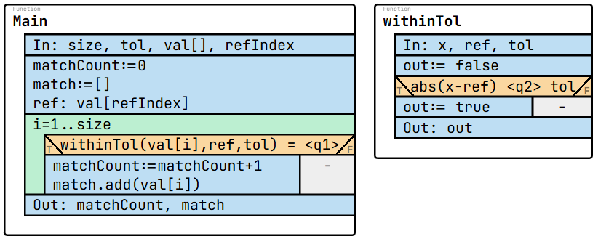
Answer: <q1> = true, <q2> = “<=”
5. When does a value qualify to be included in the result?
Answer: When its distance from the reference value is at most the given tolerance.

